Published: April 4, 2017 | By: Bobby Gailes | Posted in: Taking It to the Streets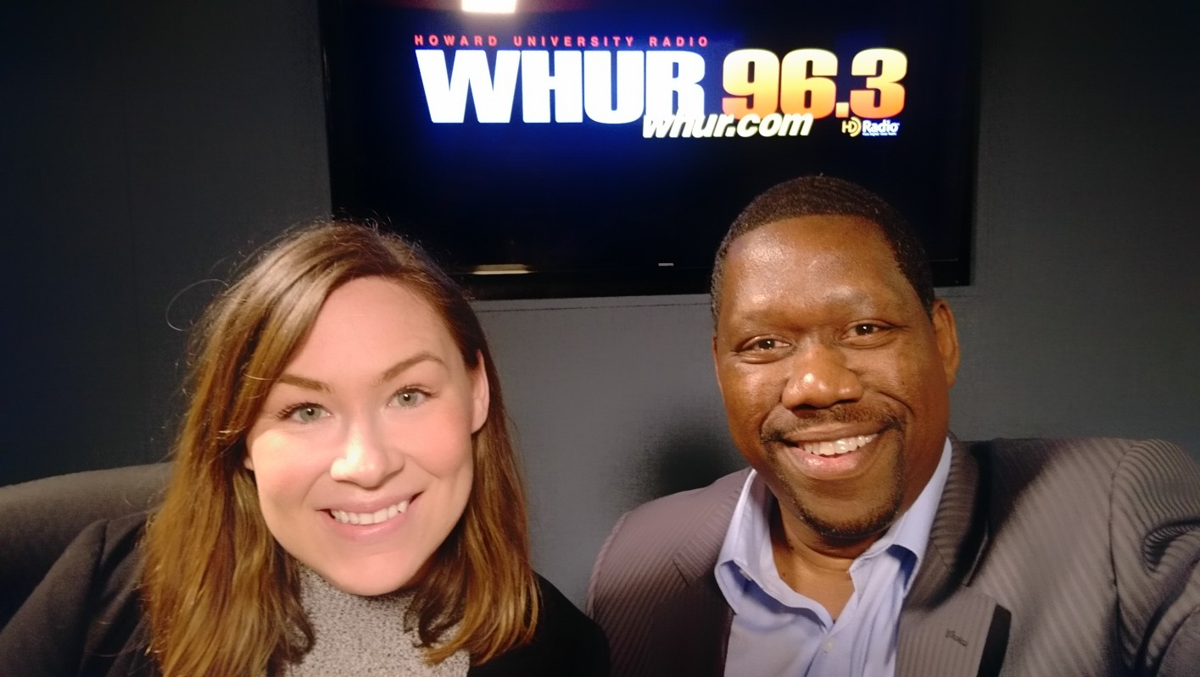
Are you at risk of losing your home or are you behind on your taxes. I have details this morning about free legal clinics taking place this month in Prince George’s County. My guest is Ms. Sydney Dunning – Attorney with the Pro Bono Resource Center of Maryland.
The Pro Bono Resources Center of Maryland is offering free Tax Sale Clinics where residents can get free legal help during the month of April at various locations through out the county. To pre-register, go here
Tune in to Taking it to the Streets, weekdays at 6:46, 7:13 and 8:13 on the Steve Harvey Morning Show on 96.3 WHUR.
Follow me on facebook and twitter at @bobbygailes for updates and to stay connected.

